District V Vice President Celebration

RENEE CLEMENT
Honoring Renee Clement
2024-2025 District V Vice President
This event is sponsored by the Eastern Michigan Council and Cardinal Crossroads Council
JULY 11 & 12, 2025
KENSINGTON HOTEL / 3500 S. State Street, Ann Arbor, MI 48108
Souvenir Program Advertising
You may advertise your business, promote your event, send Renee a message, and much more. Attendees are from Michigan, Indiana, Ohio, and other states across the country.
THE AD SUBMISSION DEADLINE IS JUNE 15, 2025
Need help with your design? Submission deadline is June 1, 2025.
Ad files and payment must be received by the deadlines above.
☐ I will Pay via Zelle ☐ I will mail a CHECK made payable to ABWA
☐ I will Pay via PayPal* to Financial Chair Jo Ann Huebner
www.abwa-emc.org/dvp-luncheon 331 Antoinette Dr., Rochester Hills, MI 48309
*Fees will be added to all PayPal payments.
AD SIZES AND COSTS (see pages 2 thru 4 for layouts): Email your completed ad (pdf or jpg 300 DPI)
CODES: V = Vertical, H = Horizontal, FP = Full Page to abwa.emc@gmail.com
Options 1V or 1H – 2.00 by 3.50 inches $35 QUESTIONS? Contact Program Chairs:
Options 2V or 2H – 3.25 by 4.50 inches $50 Cheryl Cramer CACramer.ABWA@gmail.com
Options 3V or 3H – 4.50 by 7.50 inches $100 Lynn Pomerleau store7584@theupsstore.com
FULL PAGE COVER – 7.25” wide by 9.25” tall $150
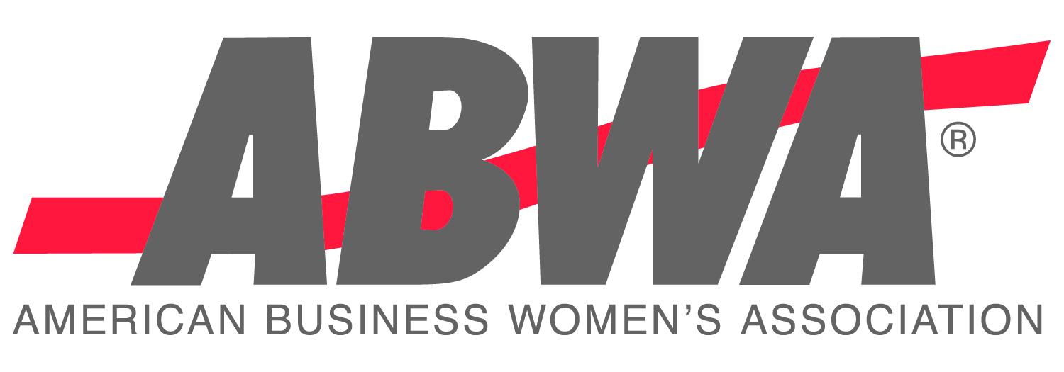
FP1 Inside Front, FP2 Inside Back, or FP3 Outside Back
COVER ads have limited availability!

COMPLETE AND SAVE THIS FILE WITH YOUR NAME. Use the tab key to go from field to field below.
CONTACT: |  |  |  |  |  | EMAIL:
Name of your company or organization:
STREET ADDRESS: |  |  |  |  |  |  |  | TOTAL PAID: $
City, State, Zip:
Phone: |  |  |  |  | SIZE OF AD(S) – Indicate Option Choice as shown above:
 |  |  |  |  | 1V, 2V, 3V, 1H, 2H, 3H, FP1, FP2, or FP3
To attend this event ($60 until June 1 / $70 June 2 - 11), register at www.abwa-emc.org/dvp-luncheon
KENSINGTON HOTEL RESERVATIONS $179/night – up to 4 people – before June 10, 2025
Call (734) 761-2929 to make your reservation - use code ABWA DVP
Online: https://reservations.travelclick.com/113707?groupID=4350589


RENEE’S FAVORITE COLOR IS ROYAL BLUE! LET’S WEAR IT TO SUPPORT HER!

AVAILABLE AD SIZES - VERTICAL

Option 1V
2.0” x 3.5”
Vertical
$35.00

AVAILABLE AD SIZES - HORIZONTAL

Option 3V
4.5” x 7.5”
Vertical
$100.00

Option 2V
3.25” x 4.5”
Vertical
$50.00
Option 1H
3.5” x 2.0”
Horizontal
$35.00

Option 2H
4.5” x 3.25”
Horizontal
$50.00

Option 3H
7.5” x 4.5”
Horizontal
$100.00

FULL PAGE OPTIONS
7.25” x 9.25”
VERTICAL
FP1: Inside Front Cover: $150
FP2: Inside Back Cover: $150
FP3: Outside Back Cover: $150

